Kimberly Clarisse P. Puno
6WEB – 2196
WD – 302 January 21, 2026
Midterm Lab Activity 5: HTTP Client Programming Discussion
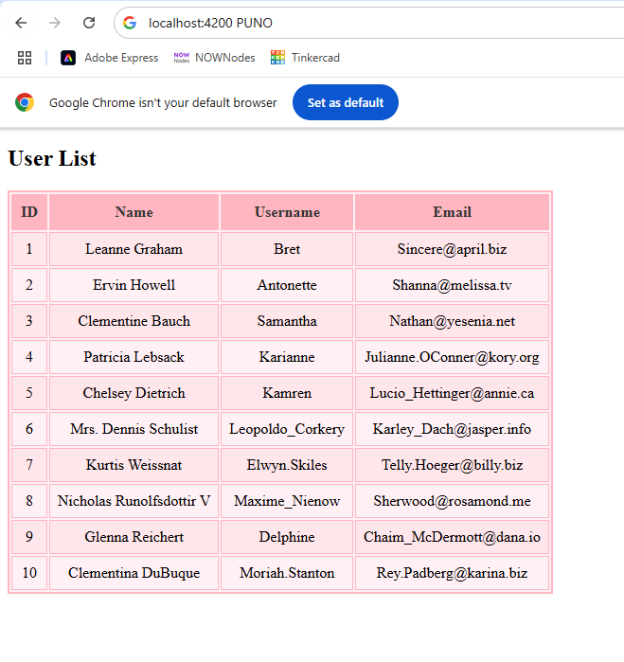

Github link
https://github.com/kmbrly-02/midterms.git

REFLECTION:
- How did you use Angular’s HttpClient service to fetch data from the JSONPlaceholder API, and what HTTP method was used in the activity?
- • I used Angular’s HttpClient service to send a GET request to the JSONPlaceholder API, which allowed me to retrieve user data remotely and display it in the application.

- What was the role of the service, model, and component in displaying the fetched JSON data on the web page?
- The service handled the API call and data retrieval, the model defined the structure of the JSON data for type safety, and the component received the data from the service and rendered it on the web page in a table format.

